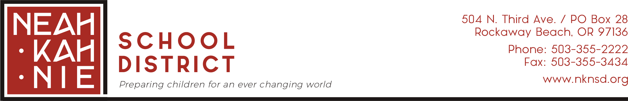
Friday, October 30, 2020

Neah-Kah-Nie Parents,

Today, the Oregon Department of Education (ODE) released new metric information for Safe Schools, Ready Learners. This metric was created with guidance and input from Governor Kate Brown as well as Oregon Health Authority. The Governor has a deep commitment to having students return safely to school. Here is the link to the Governor’s press release and information on the new guidance:
Governor Announced New Metrics

Put simply, the metric requirements have been changed to allow more counties and school districts to return safely to school. With the new metric and current data, Neah-Kah-Nie School District would be one of those districts allowed to return. The new metric will align closer to other states nationwide and is endorsed by the Center for Disease Control (CDC). School administrators and staff will review the new guidance to get a better understanding how this impacts NKN School District. The new guidance does not mean school buses will pick up children on Monday, November 2 for all day school.

NKN School District administrators, licensed staff, and classified staff understand the new guidance may create uncertainty for many of you. Limited-in-Person instruction began October 26. Students will return in a Hybrid model January 11. How the new guidance impacts this current plan has yet to be determined?

The leadership team will continue to work on creating a clear, transparent, realistic plan that keeps both safety and staff capacity at the forefront that allows us to better serve all students in person. We have been meeting with ODE, staff, students, parents, Tillamook County Health Department, and other school districts over the last few weeks to gather input and to help guide us in making our decisions. As always, student and staff health is our top priority. We know that the spread of the virus can be mitigated in schools when protocols are followed closely. Oregon’s Ready Schools, Safe Learners provides guidance to help with that. As more information is shared in the coming days we will keep you informed.

We invite you to join me and other school administrators for Let’s Chat With Paul on November 16. See the link: Let's Chat With Paul November 16

We will send out a parent survey next week to seek parent input on the new ODE guidance, the school district’s transition plan, and an opportunity for questions and concerns.

Be safe,

Paul Erlebach, Superintendent
Neah-Kah-Nie School District
paule@nknsd.org
503-355-3501

