Go Forward With Confidence Scholarship Instructions
GFWC Oregon Federation of Women’s Clubs
Scholarship Loan and Fellowship Fund
http://www.oregongfwc.org/scholarships.html

The Go Forward With Confidence Scholarship is awarded to victims of domestic violence or child abuse/neglect so that they may continue with higher education. Applicants should be at least High School Seniors who reside in Oregon and are US Citizens or permanent legal residents.

Applicant:
  - Complete the Scholarship information on the 3-page application
Send Completed Applications to: 1marac@comcast.net
Email preferred, but if not possible, send hard copy to:
Mary Accettura, 13627 SE Oatfield Rd., Oak Grove, OR 97268

  - Deadline for Receipt is March 15, 2022

  - Scholarships Awarded by May 1, 2022

  - Up to 5 Scholarships may be awarded each school year, based on number of applicants. The amounts awarded will be determined by the SLFF Committee, up to a total of $10,000,00.

  - Prior G.F.W.C. scholarship winners may apply again with an updated application plus a copy of a recent grade transcript.

  - Scholarship checks will be mailed to the student’s school after documentation of acceptance into an Oregon or another state institute of higher learning is received. This documentation must be received no later than October 1st or the scholarship will be forfeited.

Joann Wheeler
GFWC Oregon Federation of Women’s Clubs
Scholarship Loan and Fellowship Fund Chairman
jwii@msn.com

2022 OFWC Go Forward With Confidence Scholarship Application
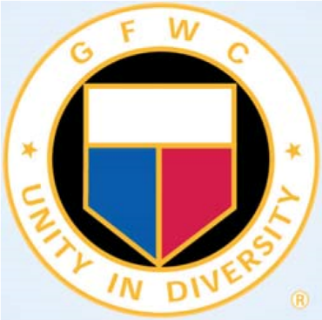
2022

Oregon Federation of Women’s Clubs
Go Forward With Confidence Scholarship

Applicant Information – All Fields Required

Name:
Date of Birth:
Home Address:
City/State/Zip Code:
Mailing Address (if different):
City/State/Zip Code:
Primary Phone: Secondary Phone:
Email:
How did you learn about the G.F.W.C. Scholarship?

I grant permission for my name to be publicized. ____YES ____NO

My Education History

High School or GED:

City, State:

Dates of Attendance:

Date of Graduation:

2022 OFWC Go Forward With Confidence Scholarship Application
Page 1

Other High School or GED:

City, State:

Dates of Attendance:

Date of Graduation:

College:

City, State:

Dates of Attendance:
Course of Study / Degree earned:
Date of Graduation:

My Education Goal

Area of Interest:

Are you currently enrolled in an accredited public or private post-secondary or vocational institution? ______yes ______no

Estimated graduation date:

Questionnaire
Each answer should be 150-250 words. Use additional pages if necessary.

- Explain your educational goals and how this scholarship will help you achieve your career goals.

2022 OFWC Go Forward With Confidence Scholarship Application
Page 2

- Tell more about yourself and how your experience as a victim of domestic violence or child abuse impacted you and your future goals.

- List any/all community-based or volunteer activities you have been involved with to improve your life and the lives of others.

Eligibility: (please check)

______ Must be at least a Senior in High School

______ Must reside in Oregon

______ Must be a United States citizen or permanent legal resident

______ Must be a victim of domestic violence or child abuse/neglect

Application must be submitted with the following document:

______ Reference letter from a Domestic Violence counselor or DHS
Caseworker on formal letterhead. on agency letterhead

2022 OFWC Go Forward With Confidence Scholarship Application
Page 3
17. Cari Wood
4441 Northwest Way
Redmond, OR 97756 9/03 541-280-3082 (cell)
ki2@hotmail.com

18. Ana Worley
13787 SW Peninsula Dr. 10/15
Terrebonne, OR 97760
503-522-6155
amw_4477@yahoo.com

19. Stephanie Worley
2118 SW Meadowbrook Dr.
Redmond, OR 97756 9/15
503-522-6170 (cell)
luba23@yahoo.com

