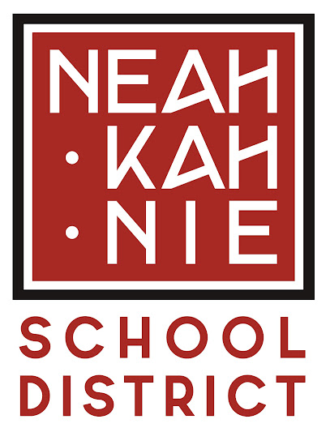

Student Investment Account
Annual Report

Reflection 1:
What changes in behavior, actions, policies, or practices has the district observed related to SIA implementation during the 2021-22 school year? How does the district see these changes contributing to the goals and outcomes in the SIA plan?

Neah-Kah-Nie School District students have significantly benefited from SIA implementation during the 21-22 school year. One area of change was that each elementary building implemented on-site preschool with the capacity for 20 students. Staffing and services were doubled in order to make this occur and both programs were full during the 2021-22 school year with waiting lists. This was an enormous undertaking that garnered increased participation from preschool families, which will, in turn, help Neah-Kah-Nie staff better serve students as they enter kindergarten.

Another change in practice was the dedicated time of the Literacy Coach to support the implementation of the Response to Instruction and Intervention (RTII) model at the middle school level. This position became critical for the support of teachers and teams in order to provide the additional strategies necessary for students to find success in literacy across content areas. As the middle school continues to refine this process, they envision adjustments to their team meetings and schedule to make interventions even more effective. Some of those plans have already been implemented during the 2022-23 school year. The team continues to seek out training and model RTII schools at the middle school level since most examples come from the elementary level.

Reflection 2:
What barriers or challenges to SIA implementation has the district experienced that are helpful for the community and/or state leaders to be aware of? What adjustments, if any, did the district make to the SIA plan as a result of these challenges?

Neah-Kah-Nie School District has struggled to find bilingual employees to implement the third strategic goal of supporting linguistically inclusive communication and outreach. Despite having the Spanish Language Family Resource Coordinator/English Language Development position open for over a year, there have not been any qualified applicants. Therefore, the unfilled position will be transferred to the general fund portion of the budget and will be discussed as a reduction for the 2023-24 budget year.

This position would be highly beneficial in meeting this strategic goal, but Neah-Kah-Nie has been unable to fill the vacancy and finding ways to communicate quickly and effectively with families has been a challenge. During the 21-22 school year, the district was able to contract with local private citizens who had advanced degrees to complete written translations for specific documents or to translate during certain scheduled meetings on an as needed basis.

Reflection 3:
SIA implementation includes ongoing engagement with all students, focal students, families, staff, and community partners. How have relationships with or between those groups changed and/or been maintained throughout the 21-22 academic year? Consider the Community Engagement Toolkit and where the district efforts might land on the Levels of Community Engagement spectrum as the district completes this response.

Monthly parent meetings at Nehalem Elementary School as well as annual parent, student, and staff surveys shape the goals of the building. Juntos programming is gaining traction at the high school level with the support of the English Language Development instructor to engage emerging bilingual students and families. Community partnerships continue to expand as our Family Resource Coordinators connect with ways to provide support to our students through necessary supplies via food, clothing, shoes, hygiene, school supplies, and more. Additionally, the partnership with the Rinehart Clinic through the Student Health and Wellness Center is allowing students to miss less class by seeing a qualified health professional onsite, if their family chooses. Monthly meetings occurred between district personnel and clinic staff in the planning and implementation for the clinic.

Moving into Integrated Guidance during the 2022-23 School Year, Neah-Kah-Nie is always hoping to engage more community, staff, and student sub-groups in order to gain as many stakeholder voices as possible in the decision-making process of goal setting.

Reflection 4:
As you think about what guided the district’s choices and prioritization efforts in this last year of SIA implementation, what stands out? How will what the district learned last school year impact future SIA implementation efforts?

Neah-Kah-Nie Middle School and High School students utilized the Family Resource Coordinator (FRC) at a high rate, sometimes beyond the available capacity, for weekend food bags, clothing, sports equipment, and hygiene supplies, so the FRC sought out additional community partners. Homelessness continued to emerge as an area of prioritization for our students.

While not a focus of the SIA funding, Neah-Kah-Nie elementary schools had increasing numbers of food bags going home weekly to assist students in need. We continued to seek out partnerships for student supplies, clothing, food, and hygiene needs. At the high school level, increasing numbers of food bags were going home weekly with foodbank and community donations continuing to expand. While the generosity of our community is astounding, so is the magnitude of the need. This area of concern combined with the mental health needs that often coincide with the tangible needs continue to emerge as areas for future SIA efforts.

